AI ASSISTED CODING
LAB TEST-04
H.NO:2403A51182 SET :08
BATCH NO:06
Name: H.V.S.Vyshnavi

Q1)
PROMPT:
Convert the following R machine-learning pipeline into modern, idiomatic Python using scikit-learn.
Follow these rules:
- Maintain the same data-processing logic, model type, hyperparameters, and train/test splits.
- Replace all R-specific libraries with their closest Python equivalents.
- Use pandas, numpy, and scikit-learn.
- Show a complete runnable pipeline

CODE:
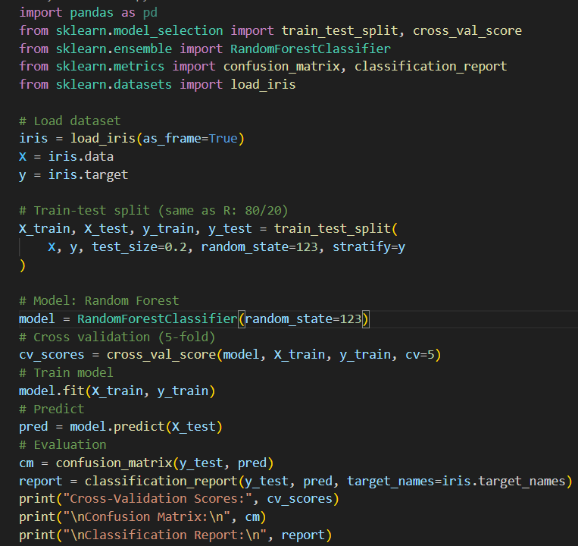
OUTPUT:
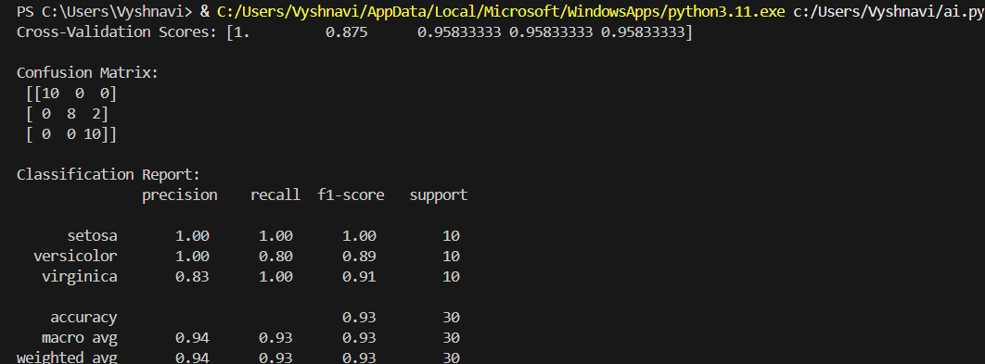

OBSERVATION:
1.Data Handling
- caret::createDataPartition ➜ train_test_split(... stratify=y)
- Ensures identical class balance as R.
2. Modeling
- caret uses Random Forest from randomForest package by default.
- Python uses RandomForestClassifier from scikit-learn.
3. Cross-Validation
- R: trainControl(method = "cv", number = 5)
- Python: cross_val_score(... cv=5)
4. Evaluation
- R confusionMatrix ➜ Python’s confusion_matrix + classification_report.

Q2)
PROMPT:
1. Maintain the same functionality and execution order as the procedural version.
2.Use classes, constructors, attributes, instance methods, and helper methods appropriately.
3.Keep the Python code runnable and well-structured
4. After translation, explain the differences between the procedural and OO designs.
5. Generate a simple test plan to validate OOP class behavior.
CODE:
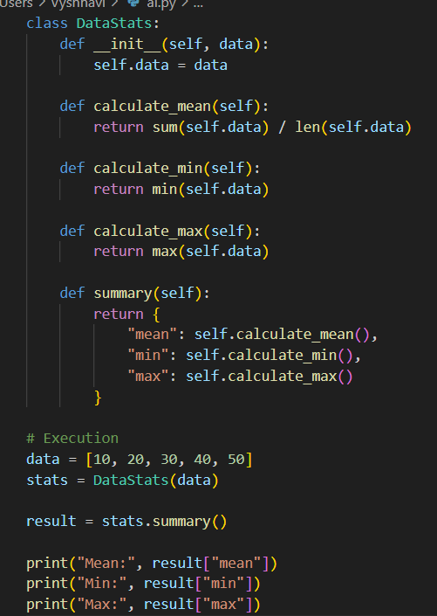

OUTPUT:
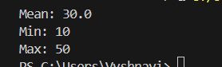

OBSERVATION:
Procedural | OOP
Functions executed directly | Logic encapsulated in a class
Global variables | State stored in self.data
No structure | Clear method structure (calculate_mean, summary)
Hard to reuse | Easily reusable: just create a new object

